University of the People

MATH 1281 - Statistical Inference

Unit 8 Written Assignment 8

Liang Xiao

# Logistic Regression Analysis: O-Ring Damage and Temperature

## a. Logistic Regression Output

The logistic regression model was fitted using JASP with 'Damaged' as the dependent variable and 'Temperature' as the explanatory variable. The model output includes both a null model (M₀) and a model including temperature (M₁). Below is a capture of the JASP output used in this analysis.

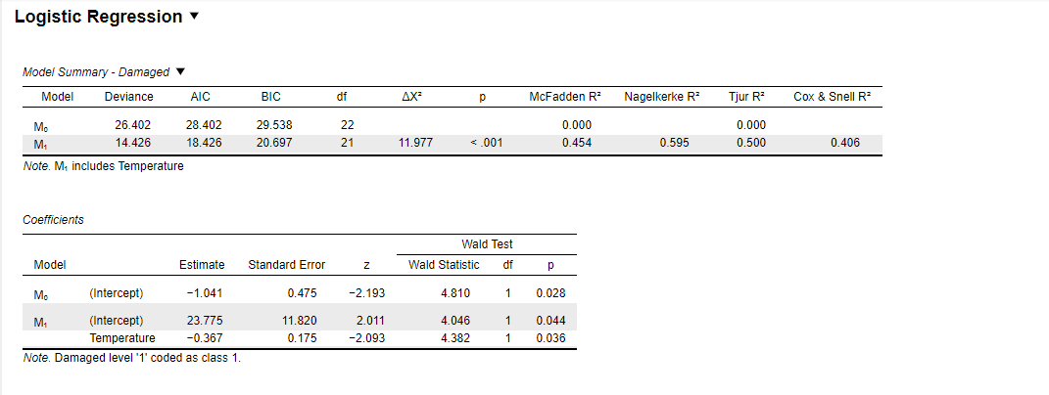

## b. Logistic Regression Equation

The fitted logistic regression equation based on the JASP output is:

log(p / (1 - p)) = 23.775 - 0.367 × Temperature

## c. Statistical Significance of Temperature

The p-value for the Temperature coefficient is 0.036, which is less than the 5% significance level. Therefore, we conclude that the β estimate for Temperature is statistically significant. This suggests that ambient temperature has a statistically significant impact on the probability of O-ring damage.

## d. Interpretation of Temperature's Effect

Yes, based on the output, it is justified to say that O-ring damage is associated with temperature. The model including Temperature (M₁) significantly improves fit over the null model (M₀), with a likelihood ratio test value ΔX² = 11.977 and p < 0.001. The negative coefficient (−0.367) for Temperature indicates that as temperature decreases, the probability of damage increases.

## e. Model-Estimated Probabilities

Using the logistic regression model, we estimated the probability of O-ring damage at various temperatures:

|  |  |
| --- | --- |
| Temperature (°F) | Estimated Probability of Damage |
| 51 | 0.817 |
| 53 | 0.739 |
| 55 | 0.642 |
| 57 | 0.526 |

These results illustrate that the risk of O-ring damage increases as ambient temperature decreases.